Contents
Analysis 2
An outline of the problem 2
Stakeholders 2
How the program can be solved using computational thinking 3
Thinking Abstractly 3
Thinking ahead 3
Thinking procedurally 4
Thinking logically 6
Thinking concurrently 6
Conclusion 6
Interview 7
Interview plan 7
Interview script 7
Interview review 9
Software 9
Hardware requirements 9
Design 10
Systems Diagram 10
Explanation of each module 11
Usability features 12
Algorithms 14
Key variables 19

Test data
Acceptance testing

Analysis

An outline of the problem
For my project I am making a recreation of the game poker: Texas holdem. This is a card game involving 2 pocket cards and 5 community cards where your goal as the player is to have a better set than your opponents, whilst strategizing how to feign your hand while deducing what sets your opponent has. You will be able to play against both real humans and bots

For this to work, the game will require card generation, a betting system involving checking, raising or calling, an evaluation system of all the potential sets that can be made, and a comparison system between one player`s set and other players set.

Stakeholders
As poker is usually a game involving betting and gambling, the target audience would be those who are legally able to do so. However, since this project is a way to play without real money, it instead will appeal to those who want to play/ practice Texas holdem and enjoy the psychological deduction without the risk of losing their own money.
Due to the previous factors the games target audience will be around 12+
I have selected a user to personify my target audience, Harry John Close, a 17-year-old student who holds an interest in card games like poker. I also have regular contact with Harry as he’s usually in the same computing class as me.

How the program can be solved using computational thinking

Thinking Abstractly
I need to decide what to include/ remove from this game for it to function well. This is why abstraction is perfect for this

Abstraction for Poker:
- Remove all aspects of gambling as it would gatekeep the game as well as make it too similar to other poker simulators
- Include visuals for all 52 cards
- Add a computer thought system
- Add a menu to help users navigate the game

Thinking ahead
Thinking ahead involves planning out what you want and what will be needed, helping build structure to the code.
- I would write in python as it’s a good code to write software in and I’m familiar with it
- Inputs would involve clicking on buttons like “bet” and keyboard inputs for when a quantity of chips is needed
- Outputs will display the winner of each game, as well as what the winning hand was, the users hand, and the amount of chips won/lost

Thinking procedurally
Similar to thinking ahead, it breaks the problem into smaller problems that are easier to handle, creating better structure

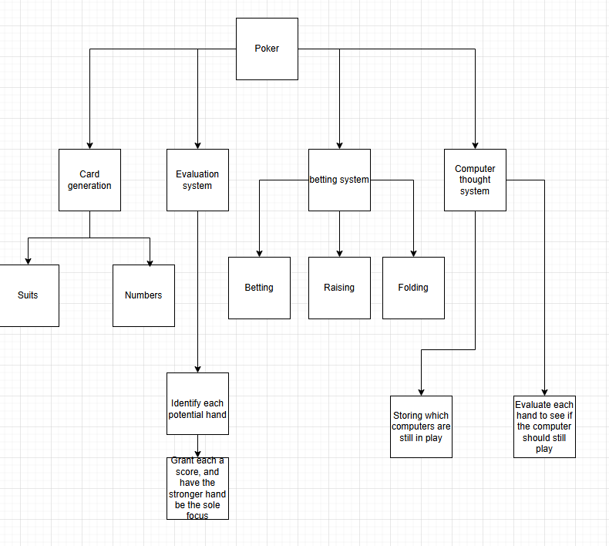

Card generation
Have the code generate as many cards as needed, determined by the number of players. Each card needs a number and a suit. There cant be 2 of the same card in one game. If the number is an 11, 12 or 13, its stored as a number but when displayed will show jacks, queens or kings respectively. If the number is a 1, then it will be displayed as an ace but hold the value of a 1 and 14 simultaneously

Evaluation system
By comparing the 2 pocket cards and the 5 community cards, the user can make a set. In order, the sets are high card (No set), a pair, 2 pairs, 3 of a kind, a straight (5 numbers all in sequence), a flush (5 of the same suit), full house (a three of a kind and a pair), 4 of a kind, Straight flush (5 concurrent numbers with the same suit)
The strongest hand able to be made will get the highest score
Theres also a minirank, where if the same set is made, then the higher minirank will decide, like 3,3 beating 2,2.

Comparison system
Once the evaluation function is finished, it stores the best hand in a record variable.
Then when the function is called again, this time with 2 different pocket cards, it determines which 2 players have a stronger hand, and stores the better set as the current winner and the record hand. This continues for all players.
This system will also exist for Mini rank, only when the scores of each set are the same
In the event of an actual tie, the game will print it’s a tie and split the pot between the tying winners

Computer thought system
The computers will need to evaluate there hand at each stage of the game and decide if their hand is worth keeping. This will be done by scoring there hand even when all 7 cards aren’t displayed, considering what they already have and what sets they could gain. There will also be aspects of rng to whether the computer will keep or fold their hand, as well as allow them to bluff even if they have a bad hand.

Thinking logically
Helps to solve the more logistical issues of the code

When the betting sequence finishes, the next cards are revealed, then the betting sequence restarts by recalling its function

Thinking concurrently
This is useful for thinking about how to make my solution more efficient when the solution is in use, such as creating all the cards at the start instead of recalling a function that makes a small amount of new cards each cycle

Conclusion
The previous examples have demonstrated that the features of my problem can be solved using computational thinking, making it suited for a computer program. These methods are useful for giving the problem some structure, and hence making it easier for me to solve
If all problems are solved, then stakeholders will be able to play a full recreation of poker, with added computer opponents and removing the need to gamble

Interview

Interview plan
This interview will be constructed to find the wants of the user and will give direction to how the code will be built. These questions are being tailored to Harry, a person already familiar with Card games like poker
The main three headings for this are, what makes normal poker good, what type of visuals should the game use, how important is multiplayer?

What makes poker good
-What introduced you into poker
-Why do you think it’s so popular
-What’s your personal favourite aspect
What visuals should the game use
- What do visuals on other poker games add to the experience
-Should a recreation of poker try to be as lifelike as possible, or aim to embrace that it’s on a device

How important is multiplayer
- What would local multiplayer add to the experience
- What would online multiplayer add to the experience
- How important is it that the game be able to be played offline with bots

Interview script
What makes poker good
-What introduced you into poker?
Seeing Poker matches played online
-Why do you think it’s so popular?
How easy it is to understand yet so difficult to master, as well as the potential to win money
-What’s your personal favourite aspect?
The feeling when you outplay someone by bluffing, especially when winning a large amount of chips

What visuals should the game use
- What do visuals on other poker games add to the experience?
In Balatro, it helps the indie and relaxed feel of the game. In PokerStars, it makes the user feel they are playing the exact game of poker as if they were sitting around a table
-Should a recreation of poker try to be as lifelike as possible, or aim to embrace that it’s on a device?
Since this isn’t trying to put a spin on the game like Balatro, it may be good to stick with realistic visuals. However, a different art style would help give the game distinction

How important is multiplayer
-What would local multiplayer add to the experience?
Allows friends to play with each other without physical cards and without gambling
-What would online multiplayer add to the experience?
Online multiplayer would allow users to play against other thinking humans easily, however, it would be much more difficult to difficult and maintain
-How important is it that the game be able to be played offline with bots
It allows players to get a feel for the game before heading online, and serves as a good way to practice even when internet isn’t available

Interview review
This interview was performed to see what the stakeholder believed would elevate this game to make it better

For visuals, we agree that a distinctive art style is good, so the style will be revolved around vintage cards to keep it classic but distinctive
For multiplayer, we decided to incorporate local multiplayer as well as Playing against CPUs, however since this is a small-scale project expecting an online player base to be maintained is too unrealistic, and so will be omitted

Software

Hardware requirements
Since the game will be pixel art, it will not be graphically challenging and therefore will be available on any modern mobile device.
This project is not fit to be on any modern console it is meant to be a free, simple way to play poker, and free alternatives are not liked on modern consoles. Also Poker would feel wrong with controller inputs.

Design

Systems Diagram
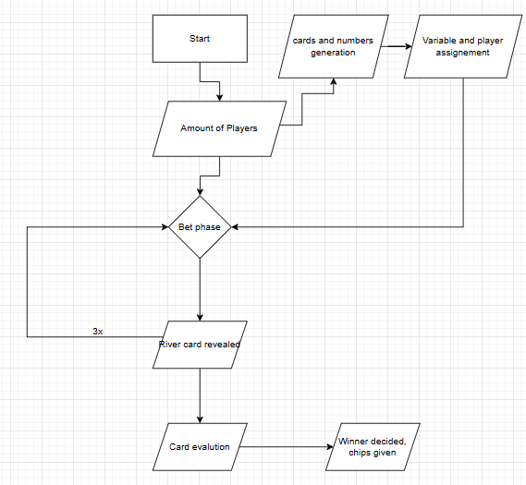
Using a simplistic Diagram structure ensures that the essentials of the program are prioritised while allowing solutions to each problem can be solved without worry of impacting other parts of the program.

Explanation of each module
Amount of players
The program immediately needs to know how many players is in a round, as this allows it to generate the correct amount of cards based on the total player count. There is a player minimum of 2 and maximum of 23

Cards generation
Generates a random suit and a random number between 1 and 13, then combines these numbers into a single variable that gets added to an array. If that exact card is already in the array, it regenerates the card until its unique. This is why the player count must max at 23, as with 24 players it’s impossible to have enough unique cards.

Variable and player assignment
After generating the array cards with numbers 11 12 and 13 get converted into their poker name equivalent, so jacks for 11 queens for 12 and Kings for 13. Then each player gets to see their 2 cards written as (Rank) of (Suit)

Bet phase
Players can choose to check or bet after seeing their cards. If a bet is made by anyone, every other player must choose to match that bet, raise that bet, or fold and give up. CPU players are capable of betting

River card
After betting, the river cards are revealed. On the first cycle, 3 cards are revealed, then on the second and third cycle 1 extra card is revealed each. These cards can be used by any player, and are added to each player’s personal array

Card evaluation
After everyone has finished betting, each players cards are sent to the evaluation function, where 5 river cards and their 2 pocket cards are put into an array, and are check to see if that array contains any poker hands, such as pair or flush.
Winner decided
After a player makes a hand, the value of their hand is stored in variables like Rank and Minirank, then their name is put as the variable “winner”. After the next players hand is scored, it compares the values of Variables like Rank and Minirank, and if they are determined to have a stronger hand, their player id replaces the old winners ID, and the Rank variables get updated with what the winner had.
After all players are compared, the winner gets chips that were accumulated through the game, and stores that value in a list that gets carried between games.

Usability features
Below are several images from other poker related games that will be used as a reference for my user interface

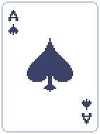 (The ace of spades from Balatro)
Each of the 52 cards will have a distinct visual about which suit and rank they are.
They will be pixelated like in Balatro but will not re use the same card models
As well as this, the suits of the colours will be different from the standard. Usually, spades/clubs are both black and hearts/diamonds are both red, making identifying them harder than it needs to be. To rectify this, clubs will be coloured a light green and diamonds will be coloured a light yellow.
Also, when card games use non standardised card colours, usually diamonds end up being a light blue. I have picked yellow as it relates to diamonds more than blue does, as well as I personally believe diamonds look better with yellow than blue

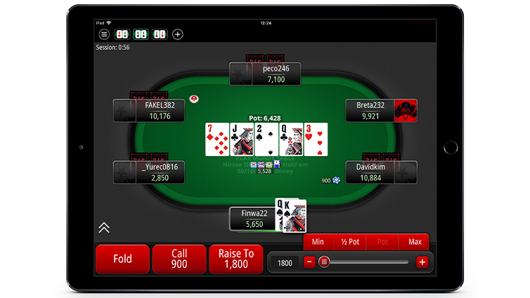
(From poker stars)

The in-game User interface will be similar to what poker stars uses, as it is a very concise way of displaying all the necessary information whilst ensuring everything looks nice.
There will be a call option however the option to bet to any value will be manual and will require users to type how much they want to bet.
The cards you can use will still be predominately displayed, but since this game will use more stylised pixel art, there might have to be slight alterations to the other aspects of the user interface to ensure everything feels natural and good to look at.
Lastly, since this project allows up to 23 players, and therefore will be very hard to recall what each player’s action was, each player’s action will be record next to their name, in an openable list.

Algorithms
Start()
Open a text file to determine if the player needs an injection of chips, so they won’t be stuck on 0 chips if they lost.
Input the number of players that will be playing this round, with boundary checks

Cards_test()
Generate a random number and suit, then combine both into one variable.
Add that variable to the list “Cards”. If that exact card is already in the list, then re-run the function and don’t add it to the list
The number will have to be made into a string so it can be concatenated with the suit

King_maker()
Before being added to the list, the number will be made into its poker equivalent.
Whatever number that needs to be checked will be written in the variable called “Placeholder”
The function will check whether the variable “Placeholder” is a 1, 11, 12 or 13. It will then overwrite the variable placeholder with either “Ace”, “Jack”, “Queen” or “King” respectively.
Lastly the variable that gave placeholder its value will be overwritten with the value of placeholder.
It will look something like:
Placeholder = *Variable*
King_maker()
*Variable* = King_maker()
Placeholder must be used as multiple different variables will need to be converted into their poker name equivalent.

Bet_()
Two players will be made to put in a big and small blind, as how poker works
The First player will be given the choice to call the blind, fold or raise the blind.
After making any decision, the next player/computer gets to make their decision
If any player folds, their player id gets sent into a list. Later, that list will be used to determine who’s still in the game, and who’s results need to be processed
If any player raises, then the cycle will repeat back until the player before that who made the bet, therefore every player will have to put the same amount of chips in, or folded before that.
Any bets made will be added to the variable “Pot” which gets added to by all players

Computer_Thinking()
The computer players will be given the ability to decide whether they should keep playing with the cards they have or not.
This is done by evaluating the cards each computer has in a list.
By using the variable “Cycles” which determines how many river cards have been revealed, we can make lists using each player id`s cards and the river cards.
By conducting individual rating tests on each list (I.e. seeing if the first 2 cards are a pair or if they have 4/5 cards for a flush before the final card is revealed), the computer is given up to 100 points. Points will be given out in a randomized range depending on the strength of their hand.
There will be randomness to the behaviour of these bots, as to ensure a player can’t figure out easily the strength of a computer’s cards. They will be capable of bluffing as well, pretending they have a strong hand when they actually have bad cards. If a computer bluffs, it will have a high chance to continue to bluff, but the more chips it must put in, the higher chance it will fold instead. Bluffing will overwrite other systems of thought but will be rare for computers.
A computer will not be able to fold if it has one of the best hands possible.

Evaluation_system()
Makes two lists of the players cards to be evaluated, one for the suits of the cards and one for the rank of the cards, by using a for loop to call this function. Since this function is being called inside of a for loop, we can use i to determine which values from the Suit_list and Num_list to pull from. Finally, both lists are sorted alphabetically/numerically.
Once the lists are made, the program checks for each of the poker hands (Pair, two pair, Three of a kind, Straight, Flush, Full house, Straight flush, Royal flush):

High card
No set can be made, the value of the hand is just whatever the highest ranked card is
Pair
Using a for loop, check if a number in the list is the same as the next number in the list

Two pair
Use a variable “Counter” that increases after a pair is found. If Counter is greater than 0, and the number isn’t the same number as the previous pair, then the hand is scored as a 2 pair instead.

Three of a kind
Using a for loop, check if a number in the list is the same as the number 2 ahead in the list.

Straight
Use a library to remove duplicates from the number list.
Then using a for loop, check if a number in the list + 4 = the value of the number 4th ahead in that list. So, if the list was [3,4,5,6,7] the program would do 3+4, then see if the 4th value after that was 7.
If the list is too small due to removing too many duplicates, then the for loop is not run
If there is a 1 in the list, then the temporary list is appended with a 14, as the value of the ace is simultaneously a 1 and a 14. This double value usually doesn’t come into effect until the ranking systems; however, it must be accounted for early here as otherwise hands that are straights wouldn’t be identified as such

Flush
Using a for loop, check if Suit_list[i] = Suit_list[i+4].
If they are the same, then there are 5 consecutive suits in the list, and therefore the player has a flush

Full house
Check if both a pair and a three of a kind was scored. Check they are different values by storing what rank the pair was, and if it’s the same rank as the three of a kind.
This must be done after two pair, as every full house will have a two pair in it, and the only way to distinct them is by scoring it as a two pair first, then overriding the variable score with the value given from a full house

Four of a kind
Using a for loop, check if a number in the list is the same as the number 3 ahead in the list. Some parts of the code are harder than others.

Straight flush
First, check if both a straight and flush has been made with that hand.
Remove duplicates from the number list again, except this time remove the value in the Suit list corresponding to the removed values, so if the second value in the number list was removed, then the second value in the suit list will be removed.
If Num_list[i] + 4 = Num_list[i+4], then check if Suit_list[i] = Suit_list[i+4]
If both conditions are true with the same value of I, then the hand is a straight flush
Royal flush
Same as a straight flush, but if the last value is 14, then it is given a higher score, used to given distinction to the strongest hand in poker.
Ranking_system()
Each hand will give a score that directly corresponds to the hand (I.e pair will give 2 and two pair will give 3) which makes displaying a players score easy
Scoring will start at the weakest hand, so that if a player has both a pair and a full house, then the program can safely overwrite score with no issues
As well as this, each hand will have a minirank, used to compare which hand is stronger if both players have the same type of poke hand (I.e, I pair of 10`s will be stronger than a pair of 2`s). For most hands, the minirank will be the set, so with a three of a kind, the minirank would be the card you have three of.
For straights and flushes, the minirank will be the highest value in either set.
On top of this, for two pairs and full houses, a second minirank value will be needed as if the minirank is the same between two hands, then the value of the second pair will need to be the tie breaker.
Finally, hands that don’t use all 5 cards also have something called a “Kicker”. If 2 players have the same value hand (I.E both have a pair of 5`s), then the tiebreaker is who has the highest value card after that. If that card is the same, it repeats until a 5th card is used anywhere, as poker rules say that you must make the best possible 5 carded hand.

After a players hand has been evaluated, it is compared with the current winners hand, by comparing first if the Score is greater than the previous winners score. If it is greater, then all the current players values (Score, Minirank, Second minirank) get set as the record values that will now be competed against.
If the Score is the same, then the minirank is compared, and follows the same rules as when comparing the score. This continues for all the Comparing values.

Once a winner has been determined, then the value of the pot will be added to that players list, and then the game resets.
If there is an actual tie, then the winning players id will be stored in a list and will split the prize pot between each other depending on how big the list is.

Key variables

Variable name | Data type | Explanation
Suit_option | List | List of the 4 different suits.
Suits | List | List of each suit that’s been generated.
Nums | List | List of each number that’s been generated.
Folds | List | List of players who are no longer in play.
Cards | List | List of each card that’s been generated, a combination of suits and numbers.
Cycles | Integer | Number that determines how many times the betting phase has been called.
Pot | Integer | Added to by all players, Variable that stores how many chips have been played.
Score | Integer | Determines how strong the players hand is based on what type of poker hand they have.
Minirank | Integer | Determines how strong the players hand is based on the value of the cards used in a set.
Kicker | Integer | Determines how strong the players hand is based on the value of the highest card not being used a set.
Highscore | Integer | Stores the results of the variable Score in the evaluation function, to be compared with new values of score.
Record_minirank | Integer | Stores the results of the variable Minirank in the evaluation function, to be compared with new values of Minirank.
Record_Kicker | Integer | Stores the results of the variable Kicker in the evaluation function, to be compared with new values of Kicker.
Winner | Integer | Tracks which player id has the strongest hand.
Number_option | Integer | Generated randomly between the values of 1 and 13.
Num | String | The string version of number option, needed for printed and to make distinction between 11 and jacks, for example.
Suit | String | Picks a suit from the list “Suit_option” randomly, then stored as a variable.
Rating | Integer | Number that determines how strong a computer thinks its hand is.
Value | String | Converts the value of Rating into a string, and makes it easier to divide into segments the strength of the computers hand.
Choice | Boolean | Determines what the player wants to do at the start of a betting round.
Tie | Boolean | Determines if 2 or more players have a winning hand of the same strength.
Balance | Integer | Tracks the amount of chips a player has to bet with, not the amount in the pot they can win.
Computers | Integer | Determines how many CPU players will be in the match.
Placeholder | String | Used to convert different variables like pair_num and number_option into their poker equivalent.
Card_check | Boolean | Used to determine if a generated card is already in the Cards list.
Straight_check | Boolean | Used to determine whether a straight has been made, helps with checking straight flush.
Flush_check | Boolean | Used to determine whether a flush has been made, helps with checking straight flush.
Computer_tracker | Integer | Determines whether it is a player or a computer`s turn when going through the evaluation system, helps with printing.
Pair_num | Integer | Determines which rank was used to make a pair. Will be updated to ensure the highest pair is counted.
Second_pair | Integer | Checks that this value is not Pair_num, and is lower than Pair_num.
Triple_num | Integer | Same as Pair_num but with Triples. Having the rank as a variable helps with displaying info to the players.
Quad_num | Integer | Same as before but with 4 of a kinds. Having these be their own variables also makes sending them to King_maker() easier.
Counter | Integer | Determines how many pairs have been made, helps to determine whether a hand has a pair, 2 pair or triples.
Num_list | List | List of all numbers that will be scored. First 2 cards Changed depending on which player id is going through the function.
Suit_list | List | List of all Suits that will be scored. Theres no need to evaluate a list of the cards, just two properties of each card.
Unsorted_nums | List | An unsorted version of the numbers, used for straight flush.
Unsorted_suits | List | An unsorted version of the suits. Sorting the list each time it needs to be used would be excessive, so 2 different lists are used.
Temp_list | List | An edited version of Num_list, used for deleting duplicates while not affecting Num_list.
Blank | List | An empty list appended to while evaluating straight flush. Helps determine which cards are part of the flush
Flush_suit | Integer | Determines which of the 4 suits is part of the flush, used for evaluation and printing.
Printer | String | Used for printing out the correct card value

